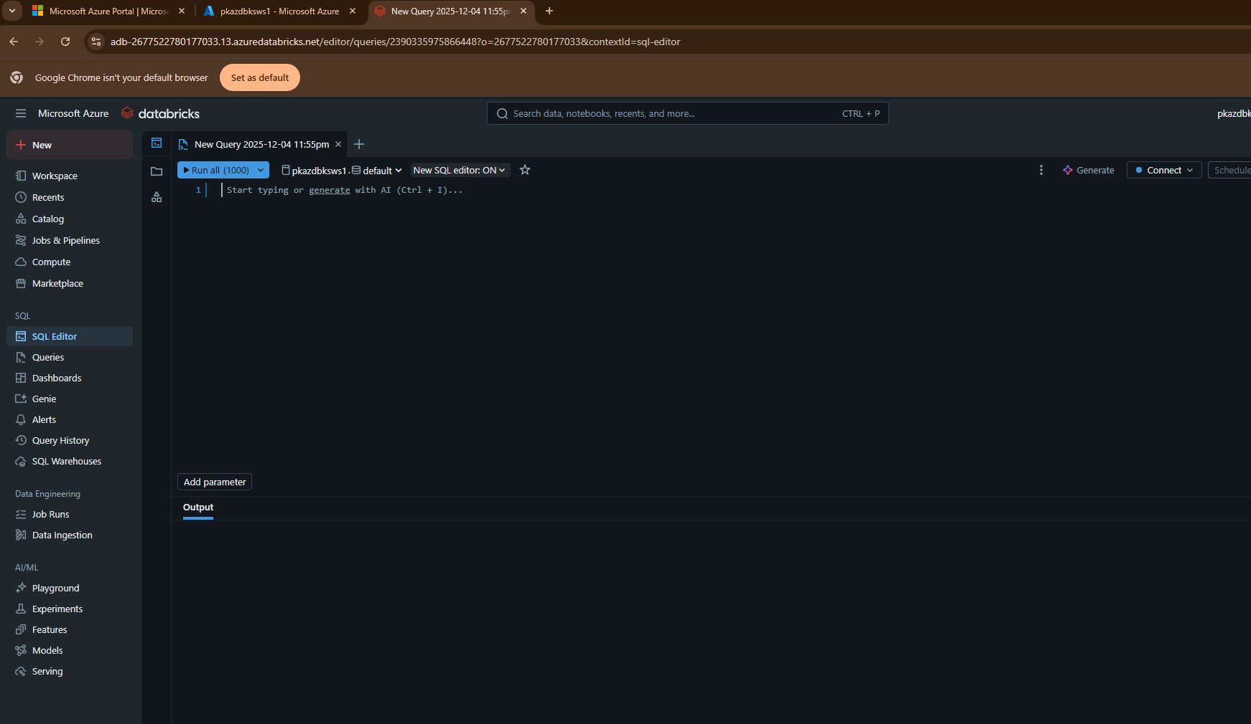

  - Top Bar (Workspace Header)
- Search bar:
Allows you to search across notebooks, tables, dashboards, queries, and other workspace assets.
- User Profile Menu (top-right with your username):
Includes settings, workspace management options, switch account, logout, permissions, etc.

2. Left Navigation Panel (Main Menu)
Workspace & Data Tools
- New:
Menu to create new assets like notebooks, queries, dashboards, clusters, jobs, etc.
- Workspace:
Folder where all notebooks, repos, dashboards, and other development resources are stored.
- Recents:
Shows recently accessed notebooks, SQL queries, dashboards, and tables.
- Catalog:
Provides access to data catalogues, schemas, and tables (Unity Catalog if enabled).
- Jobs & Pipelines:
Used for scheduling workflows, CI/CD pipelines, and production automation.
- Compute:
Section where you manage clusters, SQL warehouses, instance pools, etc.
- Marketplace:
Lets you browse and install partner data sources, datasets, and plugins.

SQL Section
- SQL Editor (current view):
Area where you can run ad-hoc SQL queries.
- Queries:
Shows saved SQL queries.
- Dashboards:
View or create dashboards built from SQL queries.
- Genie:
AI-powered chat to generate SQL, troubleshoot errors, or explore data using natural language.
- Alerts:
Create or manage alert rules based on SQL query results.
- Query History:
Logs your query executions (who ran it, when, duration, status).
- SQL Warehouses:
Area to configure the compute engine for running SQL queries (formerly “Clusters for SQL”).

Data Engineering
- Job Runs:
Shows execution logs and history of scheduled or triggered jobs.
- Data Ingestion:
Wizard to bring datasets into the workspace (e.g., ADLS, Delta Live Tables ingestion, connectors).

AI/ML Section
- Playground:
For AI interactions (like ChatGPT experience inside Databricks).
- Experiments:
Track ML model training experiments, metrics, and versions (MLflow).
- Features:
Feature store for managing ML training and serving features.
- Models:
Register and manage machine learning models (MLflow Model Registry).
- Serving:
Deploy ML models for batch inference or real-time endpoints.

3. Main Editor Panel Elements (Center)
- Run all (1000) dropdown:
Controls where the SQL query will run (select compute/SQL warehouse).
The number indicates maximum rows returned.
- Connection (e.g., "pkazdblksw1.default"):
Shows selected catalog and schema context. This defines where your SQL statements run.
- Query Editor:
The text area where you write and execute SQL queries.
- Generate (AI Assist Button):
Databricks AI can generate SQL based on natural language instructions.
- Connect Button:
Allows you to connect or reconnect to a running SQL warehouse or compute.
- Schedule:
Saves the query and schedules it to run automatically.
- More Options (three dots):
Additional options like save query, export result, format SQL, copy link, etc.

4. Bottom Panel
- Output Tab:
Displays results of executed SQL (tables, charts, execution time, errors).

Summary Table
Section | Purpose
SQL Editor | Write and run SQL queries
Queries | View/manage saved queries
Dashboards | Create graphical dashboards
Genie | AI query assistant
Alerts | Automated notifications based on query results
SQL Warehouses | Manage compute for SQL execution
Jobs | Automate/schedule workflows
Experiments/Models | ML training, versioning, deployment
Catalog | View/manage tables, schemas, data

Connectivity:
abfss://<container-name>@<storage-account-name>.dfs.core.windows.net/<optional-path>
kandatisa26
con1
csv
abfss://con1@kandatisa26.dfs.core.windows.net/csv

https://learn.microsoft.com/en-us/azure/databricks/connect/unity-catalog/cloud-storage/#storage-credentials

